

CST363 Introduction to Database Design  
**Team Project**

California State University Monterey Bay (CSUMB)

Computer Science and Information Technology (CSIT)

Dr. Wang

April 23, 2015

**Team Clarus Solutions Members**

Gracie Alderete-Fisher

Nigel De Vaughn

Clarence Mitchell

Image_6Project Summary

Every company needs a way to track employee’s reported work time, the employee timesheet is the most widely used method of tracking the time an employee has spent working. The scope of this project is to provide simple database for a basic employee timesheet system.

The basic system functions should include (and scope are as follows):

* Provide a weekly timesheet for capturing employee time
* Provide employee information (such as name, address, etc.)
* Provide department for employees
* Provide a method of tracking which projects an employee is assigned
* Provide a method for tracking and reporting total hours worked for a work week.
* Provide a method for querying employee information
* Allow time entry as little as 3 minute increments

**Solution Summary:**

For our final phase of our 2-part project we applied designs we learned and implemented them into a database system for a timesheet system. In the first part of the project, we are required to provide a summary of the scope of our project by giving a brief description of the organization, information needs, questions that need to be addressed, and the purpose of the database system.

In part 2 of the final project we had several requirements:

* At least three SQL scripts are required to be turned in
  + One to set up tables (add primary key and foreign key)
  + One for adding data to tables
  + One for queries.
* The database needs to provide the following functions:
  + Interaction with users
  + Performing queries from multiple tables
  + Query based on queries
  + Generating results that are visually appealing

**Employee & Department**

Each employee can work in one department

Each department can have multiply employees.

**Employee to Timesheet**

Each employee can multiple timesheets

Each timesheet can have one employee

**Employee and Projec**t

Each employee can have multiply projects

Each project can have multiply employees

**Project Assignment**

Used to implement Many-to-Many relationship for Employee and Project tables

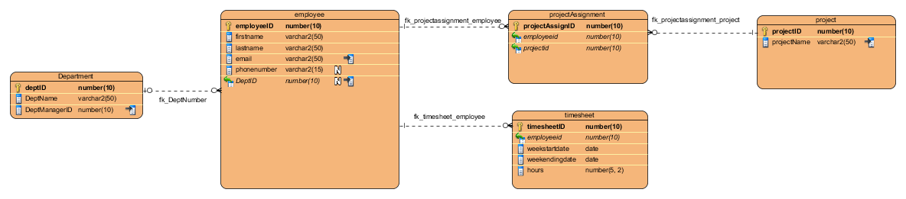

**SQL SCRIPTS**

**MENU SCRIPTS**

|  |  |
| --- | --- |
| Main.sql | The Main Menu and Driver |
| Input.sql | Displays the Input menu and calls the appropriate user data input script |
| Output.sql | Displays the report menu and calls the appropriate report script |
| Exit.sql | Displays exit message and exits |

**DATABASE CREATE SCRIPTS**

|  |  |
| --- | --- |
| Create.sql | Creates the Database and calls the table load scripts |
| loadDepartment.sql | Loads data into the department table |
| loadEmployee.sql | Loads data into the Employee table |
| loadProject.sql | Loads data into the Project table |
| loadProjectAssignment.sql | Loads data into the ProjectAssignment table |
| loadTimeSheet.sql | Loads data into the Timesheet table |

**SQL SCRIPTS (continued0**

**INPUT SCRIPTS**

|  |  |
| --- | --- |
| addDepartment.sql | Gets user input and inserts data into the department table |
| addEmployee.sql | Gets user input and inserts data into the Employee table |
| addProject.sql | Gets user input and inserts data into the Project table |
| addProjectAssignment.sql | Gets user input and inserts data into the ProjectAssignment table |
| addTimeSheet.sql | Gets user input and inserts data into the Timesheet table |

**REPORT SCRIPTS**

|  |  |
| --- | --- |
| queryall.sql | Displays a series of formatted queries of all table data |
| queryEmployee.sql | Get an employee number and displays the looked up information in a formatted query |